Project Design Phase-II
Technology Stack (Architecture & Stack)

Date | 04-10-2026
Team ID | SWTID-2026-1447
Project Name | Import Data using Transform Maps (Spreadsheet)
Maximum Marks | 4 Marks

Technical Architecture:
The architecture of the solution is shown below, followed by the components and the application characteristics.
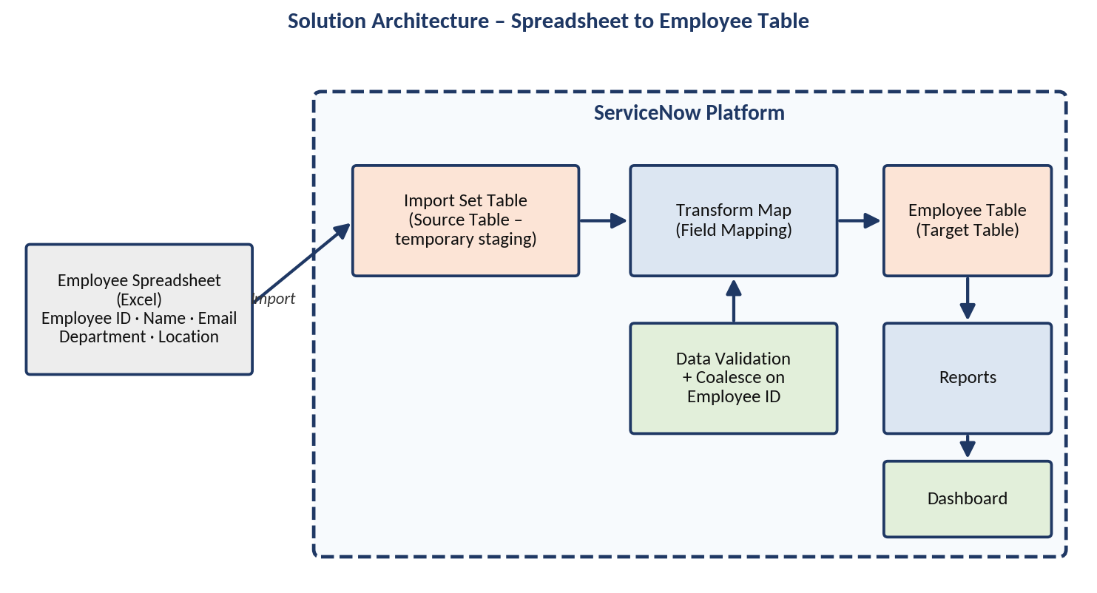
Figure: Technical architecture – spreadsheet to Employee table, reports and dashboard
Table-1: Components & Technologies:
S.No | Component | Description | Technology
1. | User Interface | How the administrator interacts with the solution | ServiceNow web interface
2. | Data Source | Spreadsheet containing Employee ID, Name, Email, Department and Location | Excel spreadsheet
3. | Application Logic-1 | Temporary storage and processing of the uploaded data | ServiceNow Import Set / Import Set Table
4. | Application Logic-2 | Mapping of source fields to target fields; Coalesce on Employee ID | ServiceNow Transform Map
5. | Application Logic-3 | Checking that imported data is correct and complete | Data validation of imported employee data
6. | Database | Target table holding the employee records | ServiceNow Employee table
7. | Reporting | Visual analysis of employee data by Department, Location and other fields | ServiceNow Reports and Dashboards
8. | External API | Not used in this project | Not applicable
9. | Machine Learning Model | Not used in this project | Not applicable
10. | Infrastructure (Server / Cloud) | Solution is configured on a ServiceNow instance | [Insert ServiceNow instance details]

Table-2: Application Characteristics:
S.No | Characteristics | Description | Technology
1. | Open-Source Frameworks | No open-source frameworks are used | Not applicable
2. | Security Implementations | Access to import and employee data is controlled by the ServiceNow platform | ServiceNow platform access control [Insert any project-specific details]
3. | Scalable Architecture | The same Import Set Table and Transform Map can process additional employee rows | ServiceNow Import Sets and Transform Maps
4. | Availability | Depends on the availability of the ServiceNow instance | ServiceNow platform
5. | Performance | Data is staged in the Import Set Table before it is transformed into the Employee table | ServiceNow Import Set Table

